Section 7: ELB &ASG - Elastic Load Balancing & Auto Scaling Groups

**Scalability & High Availability**

* Scalability means that an application / system can handle greater loads by adapting.
* There are two kinds of scalability:
  + Vertical Scalability
  + Horizontal Scalability (= elasticity)
* Scalability is linked but different to High Availability
* Let’s deep dive into the distinction, using a call center as an example

**Vertical Scalability**

* Vertical Scalability means increasing the size of the instance
* For example, your application runs on a t2.micro
* Scaling that application vertically means running it on a t2.large
* Vertical scalability is very common for non distributed systems, such as a database.
* There’s usually a limit to how much you can vertically scale (hardware limit)

**Horizontal Scalability**

* Horizontal Scalability means increasing the number of instances / systems for your application
* Horizontal scaling implies distributed systems.
* This is very common for web applications / modern applications
* It’s easy to horizontally scale thanks the cloud offerings such as Amazon EC2

**High Availability**

* High Availability usually goes hand in hand with horizontal scaling
* High availability means running your application / system in at least 2 Availability Zones
* The goal of high availability is to survive a data center loss (disaster)
* **Scalability vs Elasticity (vs Agility)**

| **Scalability** | **Elasticity** | **Agility** |
| --- | --- | --- |
| ability to accommodate a larger load by making the hardware stronger (scale up), or by adding nodes (scale out) | once a system is scalable, elasticity means that there will be some “auto-scaling” so that the system can scale based on the load. This is “cloud-friendly”: pay-per-use, match demand, optimize costs | (not related to scalability - distractor) new IT resources are only a click away, which means that you reduce the time to make those resources available to your developers from weeks to just minutes. |

### Why use a load balancer?

* Spread load across multiple downstream instances
* Expose a single point of access (DNS) to your application
* Seamlessly handle failures of downstream instances
* Do regular health checks to your instances
* Provide SSL termination (HTTPS) for your websites
* High availability across zones

### Why use an Elastic Load Balancer?

* An ELB (Elastic Load Balancer) is a managed load balancer
  + AWS guarantees that it will be working
  + AWS takes care of upgrades, maintenance, high availability
  + AWS provides only a few configuration knobs
* It costs less to setup your own load balancer but it will be a lot more effort on your end (maintenance, integrations)
* 3 kinds of load balancers offered by AWS:
  + Application Load Balancer (HTTP / HTTPS only) – Layer 7
  + Network Load Balancer (ultra-high performance, allows for TCP) – Layer 4
  + Gateway Load Balancer — Layer 3
  + Classic Load Balancer (slowly retiring) – Layer 4 & 7

### Auto Scaling Groups Scaling Strategies

* Manual Scaling: Update the size of an ASG manually
* Dynamic Scaling: Respond to changing demand
  + Simple / Step Scaling
    - When a CloudWatch alarm is triggered (example CPU > 70%), then add 2 units
    - When a CloudWatch alarm is triggered (example CPU < 30%), then remove 1
  + Target Tracking Scaling
    - Example: I want the average ASG CPU to stay at around 40%
  + Scheduled Scaling
    - Anticipate a scaling based on known usage patterns
    - Example: increase the min. capacity to 10 at 5 pm on Fridays
* Predictive Scaling
  + Uses Machine Learning to predict future traffic ahead of time
  + Automatically provisions the right number of EC2 instances in advance
* Useful when your load has predictable time - based patterns
  + 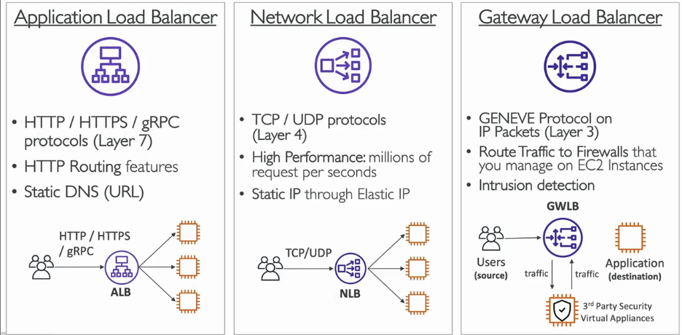

**What’s an Auto Scaling Group?**

* In real-life, the load on your websites and application can change
* In the cloud, you can create and get rid of servers very quickly
* The goal of an Auto Scaling Group (ASG) is to:
  + Scale out (add EC2 instances) to match an increased load
  + Scale in (remove EC2 instances) to match a decreased load
  + Ensure we have a minimum and a maximum number of machines running
  + Automatically register new instances to a load balancer
  + Replace unhealthy instances
* Cost Savings: only run at an optimal capacity (principle of the cloud)

